With the help of Machine learning, we have created a model to obtain the dimensional values for design 1, corresponding to cut off frequency provided by the user.

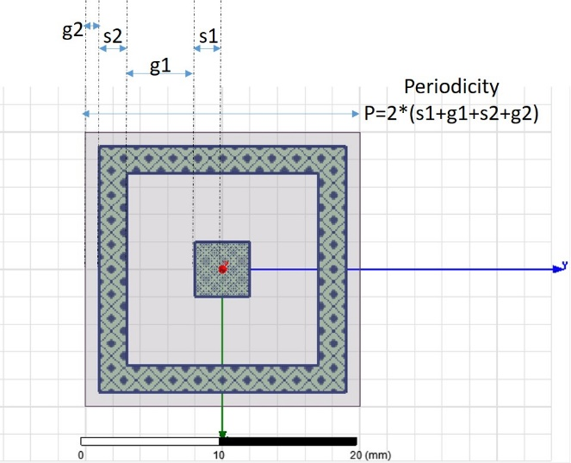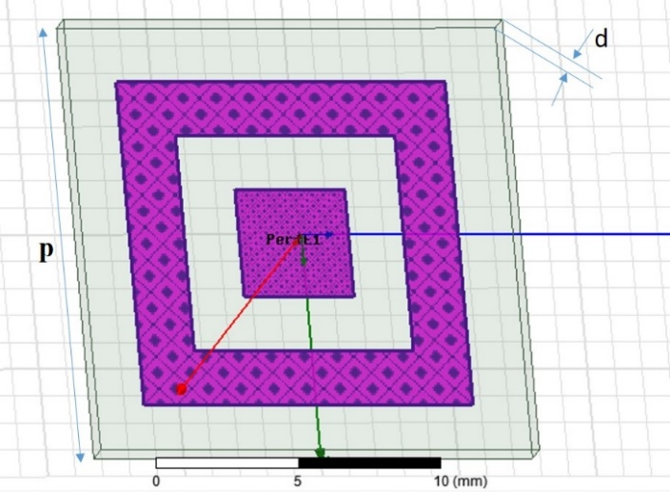

Following are few of obtained dimensional values:

|  |  |  |  |  |  |  |  |  |  |
| --- | --- | --- | --- | --- | --- | --- | --- | --- | --- |
| User defined cut-off frequencies (in GHz) | | Dimensions (in mm) obtained by using trained model | | | | Simulation result cut-off frequencies (in GHz) | | Error percentage | |
| Lower cutoff frequency | Upper Cutoff frequency |
| G1 | G2 | S1 | S2 | Lower cutoff freq | Upper cutoff freq | Lower cutoff | Upper Cutoff |
| 2 | 4 | 2.6 | 1.4 | 3.0 | 1.2 | 9.2 | 12.04 | 360 | 66.7 |
| 3 | 6 | 7.5 | 0.5 | 4.7 | 1.0 | 4.94 | 8.29 | 64.6 | 27.6 |
| 8 | 10 | 3.5 | 0.7 | 3.5 | 1.6 | 7.82 | 10.51 | 2.25 | 4.8 |
| 2 | 18 | 6.5 | 0.7 | 0.2 | 0.0 | Design invalidated |  |  |  |
| 10 | 15 | 5.6 | 0.1 | 1.8 | 1.2 | 9.24 | 15.08 | 7.6 | 0.53 |
| 15 | 19 | 3.2 | 0.1 | 1.1 | 1.5 | 14.59 | 16.81 | 2.7 | 13 |
| 18 | 19 | 0.8 | 0.0 | 1.2 | 2.1 | After 20 GHz | -------- | ----- | ------ |
| 7 | 18 | 9.5 | 0.0 | 0.8 | 0.2 | 6.08 | 18.93 | 13.1 | 4.9 |
| 9 | 16 | 7.1 | 0.0 | 1.4 | 0.7 | 8.32 | 15.53 | 7.5 | 3 |
| 11 | 12 | 1.6 | 0.3 | 3.1 | 1.7 | 9.65 | 11.70 | 12.3 | 2.5 |
| 17 | 18 | 1.0 | 0.0 | 1.4 | 2.1 | 18.82 | 19.13 | 10.7 | 5.9 |

Error has been calculated by taking simulation frequency as reference value, in both lower and upper cutoff frequency cases.

Error percentage = abs (ref value – obtained value) *100/ ref value

Following are the cases which we have used to Verify and complete the table:

Test 1:

|  |  |  |  |  |  |  |
| --- | --- | --- | --- | --- | --- | --- |
| User defined cut-off frequencies (in GHz) | | Center cutoff frequency (GHz) | Dimensions (in mm) | | | |
| Lower cutoff frequency | Upper Cutoff frequency |
| G1 | G2 | S1 | S2 |
| 2 | 4 |  | 2.6 | 1.4 | 3.0 | 1.2 |

With the above input parameters, we have got the following simulation result:



The cut off frequency obtained is from 9.20 GHz to 12.04 GHz.

Test 2:

|  |  |  |  |  |  |  |
| --- | --- | --- | --- | --- | --- | --- |
| User defined cut-off frequencies (in GHz) | | Center cutoff frequency (GHz) | Dimensions (in mm) | | | |
| Lower cutoff frequency | Upper Cutoff frequency |
| G1 | G2 | S1 | S2 |
| 3 | 6 |  | 7.5 | 0.5 | 4.7 | 1.0 |

With the above input parameters, we have got the following simulation result:



The cut off frequency obtained is from 4.94 GHz to 8.29 GHz.

Test 3:

|  |  |  |  |  |  |  |
| --- | --- | --- | --- | --- | --- | --- |
| User defined cut-off frequencies (in GHz) | | Center cutoff frequency (GHz) | Dimensions (in mm) | | | |
| Lower cutoff frequency | Upper Cutoff frequency |
| G1 | G2 | S1 | S2 |
| 8 | 10 |  | 3.5 | 0.7 | 3.5 | 1.6 |

With the above input parameters, we have got the following simulation result:



The cut off frequency obtained is from 7.82 GHz to 10.51 GHz.

Test 4:

|  |  |  |  |  |  |  |
| --- | --- | --- | --- | --- | --- | --- |
| User defined cut-off frequencies (in GHz) | | Center cutoff frequency (GHz) | Dimensions (in mm) | | | |
| Lower cutoff frequency | Upper Cutoff frequency |
| G1 | G2 | S1 | S2 |
| 2 | 18 |  | 6.5 | 0.7 | 0.2 | 0.0 |

Design was invalidated

Test 5:

|  |  |  |  |  |  |  |
| --- | --- | --- | --- | --- | --- | --- |
| User defined cut-off frequencies (in GHz) | | Center cutoff frequency (GHz) | Dimensions (in mm) | | | |
| Lower cutoff frequency | Upper Cutoff frequency |
| G1 | G2 | S1 | S2 |
| 10 | 15 |  | 5.6 | 0.1 | 1.8 | 1.2 |

With the above input parameters, we have got the following simulation result:



The cut off frequency obtained is from 9.24 GHz to 15.08 GHz.

Test 6:

|  |  |  |  |  |  |  |
| --- | --- | --- | --- | --- | --- | --- |
| User defined cut-off frequencies (in GHz) | | Center cutoff frequency (GHz) | Dimensions (in mm) | | | |
| Lower cutoff frequency | Upper Cutoff frequency |
| G1 | G2 | S1 | S2 |
| 15 | 19 |  | 3.2 | 0.1 | 1.1 | 1.5 |

With the above input parameters, we have got the following simulation result:



The cut off frequency obtained is from 14.59 GHz to 16.81 GHz.

Test 7:

|  |  |  |  |  |  |  |
| --- | --- | --- | --- | --- | --- | --- |
| User defined cut-off frequencies (in GHz) | | Center cutoff frequency (GHz) | Dimensions (in mm) | | | |
| Lower cutoff frequency | Upper Cutoff frequency |
| G1 | G2 | S1 | S2 |
| 18 | 19 |  | 0.8 | 0.0 | 1.2 | 2.1 |

With the above input parameters, we have got the following simulation result:



The cut off frequency obtained is after 20 GHz.

Test 8:

|  |  |  |  |  |  |  |
| --- | --- | --- | --- | --- | --- | --- |
| User defined cut-off frequencies (in GHz) | | Center cutoff frequency (GHz) | Dimensions (in mm) | | | |
| Lower cutoff frequency | Upper Cutoff frequency |
| G1 | G2 | S1 | S2 |
| 7 | 18 |  | 9.5 | 0.0 | 0.8 | 0.2 |

With the above input parameters, we have got the following simulation result:



The cut off frequency obtained is from 6.08 Ghz to 14.50 GHz, 14.98 to 16.03 GHz and 16.73 to 18.93 GHz.

Test 9:

|  |  |  |  |  |  |  |
| --- | --- | --- | --- | --- | --- | --- |
| User defined cut-off frequencies (in GHz) | | Center cutoff frequency (GHz) | Dimensions (in mm) | | | |
| Lower cutoff frequency | Upper Cutoff frequency |
| G1 | G2 | S1 | S2 |
| 9 | 16 |  | 7.1 | 0.0 | 1.4 | 0.7 |

With the above input parameters, we have got the following simulation result:



The cut off frequency obtained is from 8.32 Ghz to 15.53 GHz.

Test 10:

|  |  |  |  |  |  |  |
| --- | --- | --- | --- | --- | --- | --- |
| User defined cut-off frequencies (in GHz) | | Center cutoff frequency (GHz) | Dimensions (in mm) | | | |
| Lower cutoff frequency | Upper Cutoff frequency |
| G1 | G2 | S1 | S2 |
| 11 | 12 |  | 1.6 | 0.3 | 3.1 | 1.7 |

With the above input parameters, we have got the following simulation result:



The cut off frequency obtained is from 9.65 Ghz to 11.70 GHz.

Test 11:

|  |  |  |  |  |  |  |
| --- | --- | --- | --- | --- | --- | --- |
| User defined cut-off frequencies (in GHz) | | Center cutoff frequency (GHz) | Dimensions (in mm) | | | |
| Lower cutoff frequency | Upper Cutoff frequency |
| G1 | G2 | S1 | S2 |
| 17 | 18 |  | 1.0 | 0.0 | 1.4 | 2.1 |

With the above input parameters, we have got the following simulation result:



The cut off frequency obtained is from 18.82 Ghz to 19.13 GHz.